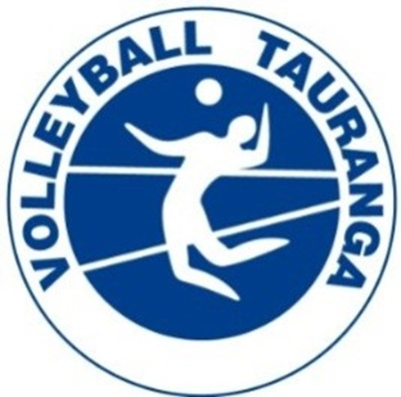

HISTORY
Tauranga Volleyball Club was established in 1974 after the popularity of school volleyball in the region in the early 1970’s.
PRESIDENTS
1974 – 1977 Ken Stevenson
1978 – 1981 Derek Perkins
1982 – 1986 Barrie Herring
1987 – 1995 Sam Kirk
1995 – May 2025 Stewart Henderson

LIFE MEMBERS
Barrie Herring, Sam Kirk , Jenny Kirk

NATIONAL CLUB CHAMPIONSHIPS
MEN 2003
WOMEN 1981, 2008, 2010 (did not drop a set all tournament) , 2018

